UGANDA RAKAI CCAFS SITE ORGANIZATIONAL BASELINE SURVEY

INTERVIEW REPORT
Contents
1.0 Introduction 1
2.0 Approach used 1
3.0 Interview Reports 2
3.1 Rakai Health Sciences Program (formerly Rakai Project) 2
3.2 Vi-Agroforestry 3
3.3 National Agricultural Advisory Services (NAADS) 4
3.4 Local Council (V) Rakai 5
3.5 Masaka Diocesan Development Organisation (MADDO) 5
3.6 Rakai Counselors Association (RACA) 7
3.7 Community Integrated Development Initiatives (CIDI) 7
3.8 Agali Awamu 8
3.9 Community Enterprises Development Organisation (CEDO) 9
3.10 NEMA (National Environmental Management Authority) 10
3.11 Co-operAid 11
3.12 World Vision – Rakai Branch 11
4.0 Overall opinion of the organisations and potential partners 13
4.1 Potential Partners 13
4.2 Organisations not recommended as CCAFS Future Partners and why? 14
5.0 Organisations that were interviewed 15
ANNEX 1: SOME PICTURES TAKEN DURING THE OBS INTERVIEWS 18

List of Acronyms

ADP Area Development Program
CBTs Community Based Trainers
CEDO Community Enterprises Development Organisation
CIDI Community Integrated Development Initiatives
CSF Uganda Civil Society Fund
HQs Headquarters
IGAs Income Generating Activities
ILO International Labour Organization
LC Local Council
MAAIF Ministry of Agriculture, Animal Industries and Fisheries
MADDO Masaka Diocesan Development Organisation
MJAP Mulago–Mbarara Teaching Hospitals' Joint AIDS Program
NAADS National Agricultural Advisory Services
OBS Organizational Baseline Study
OCBO Orphans Community Based Organisation
OVC Orphans and Vulnerable Children
PEPFAR President's Emergency Plan for AIDS Relief in Africa
PHA People Having AIDS
PLHA People Leaving with HIV/AIDS
QA Question and Answer
RACA Rakai Counselors Association
RHSP Rakai Health Sciences Program
S/C Sub County
SMS Subject Matter Specialist
VCT Voluntary Counseling and Testing

Introduction
The organizational baseline study (OBS) targeted 12 organisations that provide services and agricultural/climatic information in the Rakia CCAFS site (UG 02). The objectives of the OBS were to:-
- Provide indicators to allow CCAFS team to monitor changes in behaviours and practices of locally relevant organisations over time.
- Understand the provision of information/services at the local level that informs farmers’ decision making about their livelihood strategies in response to climate change.

Approach used
Data was collected using a simple survey questionnaire that took one to two hours depending on the activities and size of the organisation. The questionnaires were administered to 1-2 key respondents within 12 organisations that work in the CCAFS benchmark site of Rakai. Three more organisations namely: Masaka Diocesan Development Organisation (MADDO), Community Enterprises Development Organisation (CEDO), and Community Integrated Development Initiatives (CIDI), were identified as important during the process and were added to the list of 9 to make it 12 organisations. These were derived from the list of active organisations which was generated during the organizational landscape exercise in the CCAFS Village Baseline Study conducted in Kyengeza village in July 2011.

It was not necessary to translate the entire questionnaire because the caliber of majority of interviewees could all understand English. This is because most of the organisations recruit people of different tribes and from different regions of the country making it difficult to work with one local dialect. It was only in one particular case with Agali Awamu a local CBO (based in Kijuna village) where the interview was conducted in Luganda given the fact that the respondent didn’t understand English. It is important to note that a combination of Luganda and English languages were used during the interview sessions to help with probing and clarifying certain issues. This necessitated that the interviewer and note taker comprehended and pre-tested the questionnaire before administering it to the intended interviewees.

Interview Reports
This section explains how and why particular individuals were selected for the interviews in the various organisations. It also gives the justification for the 3 organisations that were added to the list for the interview. The section also covers an assessment of how the interview went and the lessons learn about the organisation in the interest of CCAFS future work.

3.1 Rakai Health Sciences Program (formerly Rakai Project)
Rakai Health Sciences Program (RHSP), formerly Rakai Project, is a research based organisation that carries out research and clinical care relating HIV/AIDS. Ms Jesca Basiima, a Medical Social Worker at Lwanda Health Centre was interviewed. Jesca was selected for the interview because she is the in-charge of Lwanda Health Centre, one of the hubs of Rakai Health Sciences Program. The Health Unit lies within the Rakai CCAFS site and Jesca was particularly selected because she was conversant with the program activities of RHSP and was willing to give information about the organization activities freely unlike other people high up in RHSP. The other reason for picking on Jesca was the fact that the headquarters of RHSP are in Kalisizo town which is beyond the CCAFS Rakai block boundaries yet her health unit was the immediate local office in the district/locality.

Assessment of how the interview went
The interview went on fruitfully – the respondent willingly shared information despite the fact she had a young baby. The interview was conducted near her home because she had to take care of a young baby. She also volunteered to give more information in form of organization documents that are annexed to the scans of her organisations questionnaire.

Lessons learnt about the RHSP
- The organisation mainly focuses on HIV/AIDS – related activities with limited focus on agriculture and food security issues, therefore there is a potential for CCAFS program to partner with RHSP to bridge this missing link.
- The organisation has a strong component of giving messages on improved food production. This can be a good starting point for any potential CCAFS interventions geared towards enhancing food security in Rakai amidst the challenges of climate change.
- RHSP is slowly promoting tree planting for mainly aesthetic reasons among the target households; there is a missing link that CCAFS can bridge by sensitizing farmers on the multiple benefits of tree planting and soil and water conservation given the water scarcity in Rakai.

3.2 Vi-Agroforestry
Vi-Agroforestry is no longer operational in Rakai district; it shifted to other regions so the available person who could share information about the NGO was a former Community-Based Facilitator by the name of Fred Nakumanyanga. Fred was selected because he had worked closely with Vi-Agroforestry in Lwanda sub-county and hence knew the locality and the program activities.

Assessment of how the interview went
The fact that a ‘second person’, who worked as a Community-Based Facilitator, was interviewed meant that scanty information was obtained on the activities of VI-agroforestry. The contact person could only explain the activities that took place in his sub-county. However, cross-checking with an agricultural extension officer who worked closely with Vi, one Kirangwa Lawrence, helped to verify the information obtained from Fred.
Lessons learnt about the organisation
Much as VI-agroforestry ended its activities in Rakai district, the communities that it worked with continued planting agro-forestry tree species for mainly fuel wood and fruit benefits. The other lesson was that it is much easier to promote fruit trees than other trees in rural communities of Rakai, since the target groups quickly see the direct befits from trees – the fruits. Therefore any interventions in the direction of promoting tree growing should consider including fruit trees for quick adoption.

3.3 National Agricultural Advisory Services (NAADS)
NAADS operates in all parishes and sub-counties of Rakai district as it is the case throughout Uganda. Mr. Lubega Abdu was selected for the interview because he has been working as an Agricultural Advisory Service provider in Lwanda Sub-county for the last 2 years. Before joining NAADS Abdu was an Assistant Agricultural Officer in Lwanda Sub-county for over 5 years. Based on that experience, it was believed that Abdu had a direct contact with communities and had versed knowledge and experience of NAADS activities at the grassroots level.

Assessment of how the interview went
The interview went on smoothly and yielded good information since the respondent knew the NAADS and agricultural extension services system at the sub-county level so well.

Lessons learnt about the organisation
It was noted that the value attached to trainings by the NAADS target population in Lwanda Sub-county is very low as evidenced by low attendance of training workshops. This was attributed to the low literacy levels in the area and the fact that some people are fed up with seminars but rather need tangible initiatives. Hence any CCAFS intervention involving sensitization has to find a way of overcoming this challenge.

3.4 Local Council (V) Rakai
Mr. Patrick Kintu Kisekulo, an L.C.V Councilor for Kasaali Sub-county was selected for interview. Patrick was nominated based on his long-term service and experience in the local council issues in the district. Patrick has also been an Executive member of Rakai district Council, implying that he is knowledgeable about matters regarding a number of sub-counties in Rakai district. The mobiliser of the OBS respondents described Patrick as an intelligent person who could explain local council strategic activities clearly.

Assessment of how the interview went
The interview went well with the respond clearly articulating the strategic activities relating to agriculture, food security and environmental conservation in the district. The respondent also shared the strategic direction of the district towards protecting wetlands and other natural resources amidst the escalating dangers of indiscriminate tree cutting and charcoal burning.

Lessons learnt about the organisation
It was noted that local councils have a strong hand in influencing the activities in the entire district. Hence any CCAFS program activities geared towards addressing climate change agriculture and food security concerns in Rakai should devise strategies of involving the local councilors.

3.5 Masaka Diocesan Development Organisation (MADDO)
MADDO operates in Masaka Diocese covering the districts of Masaka, Rakai, Ssembabule, Lyantonde and Kalangala. It boarders with Tanzania in the south, comprising the whole group of the Ssese islands in lake Victoria on the eastern side, Mbarara Diocese to the west, with Kiyinda Mityana and Kampala Arch diocese boardering all the North. Masaka Diocesan Development Organisation (MADDO) was added to the list as a locally relevant organisation because it has ongoing CCAFS related (sustainable energy, Water and Sanitation and sustainable agriculture) activities in Dwaniro, Kasasa, Kasaali and Kyebe sub-counties of Rakai district. The organisation specifically trains farmers on improved farming methods, promotes energy saving technologies, soil and water conservation, provides improved seed, promotes water and sanitation/hygiene at household level.

Mr. Ssali Fulugensio, an extension link farmer working with MADDO, was recommended for interview by the MADDO staff at the Headquarters in Masaka. The justification was that Mr. Ssali has worked as an extension link farmer in some of the most active local groups in Kiyovu Parish – Lwanda Subcounty and hence was seen as a good source of information on MADDO activities in Rakai CCAFS site.

Assessment of how the interview went
The respondent clearly articulated the program activities of MADDO enabling the interviewer to appreciate and understand some potential areas of collaboration with CCAFS.

Lessons from the Organisation
- It was noted that MADDO works towards ensuring food security and improved livelihoods of her target communities using sustainable approaches. Therefore the communities targeted by MADDO are already informed and probably need support to implement climate smart agriculture initiatives.
- It was also reported that a bigger percentage of the turn up for MADDO trainings is mainly women unless there is some monetary benefit attached. This implies that men attach more value to handouts than the trainings. This is something that has to be circumvented during future CCAFS trainings if they are to be gender-balanced.

3.6 Rakai Counselors Association (RACA)
RACA operates in Lyantonde and Rakai districts for the simple reason that Lyantode was originally part of Rakai before it was cut off to become an autonomous district. Mr Lawrence Sserunjogi works as an Administrator in RACA. He was chosen for interview because he has worked with RACA for over 10 years and hence has a wealth of field experience and information about RACA’s strategic activities. In addition, he was a willing to share the information about RACA freely.

Assessment of how the interview went
The interview was the longest given the activities implemented by RACA and the openness of the respondent. The interview revealed that in addition to HIVA/IDS awareness RACA also has a strong arm on food security and income generation through agriculture among HIV/AIDS affected/infected communities.

Lessons learnt about the organisation
It was noted that much RACA is mainly focused on HIV/AIDS Awareness and prevention; it also aims at empowering the infected/affected people to cope with HIV/AIDS through promotion of food security and income generating activities. This implies that RACA would therefore welcome any initiatives geared towards enhancing agricultural productivity and ensuring food security in her target communities.

3.7 Community Integrated Development Initiatives (CIDI)
Mr. Dan Kigula Kayongo, an Extension Officer of CIDI, was interviewed because he is one of the founder members and has been working in the organisation for close to 10 years. Above all, Dan’s willingness to provide more information whenever contacted by other researchers was also a strong point to justify his selection.

Assessment of how the interview went
The interview went on very well because the respondent was well-informed about the organisation activities. The interview was conducted in a conversational style enabling the interviewer to get an understanding of the program activities of CIDI.

Lessons learnt about the organisation
It was noted that the organisation program activities related to CCAFS program activities include sustainable agriculture, environmental awareness and conservation activities.

3.8 Agali Awamu
Agali Awamu is CBO based in Kijuna village. Much as Agali Awamu was shortlisted for interview by the CCAFS Organizational Baseline Study coordination team it was found to be a village member-based CBO with 21 members (13 women and 8 men). Nonetheless, the chairperson of the organisation was interviewed and the questionnaire is attached. The Chairperson of Agali Awamu, Ms. Immaculate Nakanwagi, was selected for interview because she is a founder member and one of the leaders of the group; hence it was believed that she had good knowledge of the CBO and its activities.

Assessment of how the interview went
Given the nature of the organisation, there was not much to share apart from the little information about the objectives and a few ongoing farm-based activities for the 21-member organisation. The interview was conducted in Luganda dialect since the respondent could only communicate freely in Luganda. At a certain stage during the interview story-telling was accommodated as a way of soliciting relevant information from the respondent.

Lessons learnt about the organisation
- It was noted that Agali Awamu is only ‘coalition of willing farmers’ who are interested in boosting their agricultural production for food security and income generation mainly. The CBO implements interrelated activities in an integrated manner with members encouraging and supporting each other morally.
- The organisation did not have any documentation or detailed records talking about their mission and vision but rather operates on mutual agreement based on ‘word of mouth’. Members just come together and agree on what/how to produce as farmers and they go ahead to produce it.

3.9 Community Enterprises Development Organisation (CEDO)
Community Enterprises Development Organisation (CEDO) has her headquarters in Kalisizo Town and has been in existence for over 10 years. Mr. Fred Kanaabi was selected for the interview because he works as a field extension worker in CEDO. From past experience with CCAFS earlier surveys where Fred has worked as a community mobiliser revealed that he is knowledgeable about CEDO’s organisation strategy and is able to explain the activities. CEDO was added to the list of organisations for the OBS because a number of its program activities such as giving out seedlings, provision of fruit trees and provision of seeds to marginalized groups in Rakai district link well to CCAFS program activities. In addition, CEDO came out as one of the important organisations working in Rakai during the village baseline study and the Participatory Action Research Site Visits to Rakai.

Assessment of how the interview went
The interview was conducted in a conversational manner to enable the interviewer and note taker understand the organisation better. It was noted that the approach used successfully brought out the key issues pertaining to CEDO.

Lessons learnt about the organisation
CEDO’s environmental awareness and conservation activities are limited to those that don’t require a lot funding since there is no specific project funding for environmental-related activities. However, listening to the field extension officer talking about the long-term plans of CEDO indicates that CEDO has a strong component on environmental related issues, which can only be strengthened with availability of funds.

3.10 NEMA (National Environmental Management Authority)
Mr. Lawrence Okiria, a Fisheries Officer attached to the Ministry of Agriculture, Animal Industries and Fisheries (MAAIF) and working closely with the wetlands division in Rakia district was selected for interview. Mr. Okiria works as a Fisheries Officer in Kakyera and Kagamba sub-counties. Mr. Okiria has also worked for over 5 years on issues of environmental protection in Wetland areas and areas around the lake shores in Rakia district. He was recommended by the Rakai Production Coordinator, Dr. Kimbugwe, because the Natural Resource Officer of the district was new in the area and was unavailable due to other special duties.

Assessment of how the interview went
The interview was conducted using a question and answer approach since the respondent had limited time due to other official duties. Nonetheless, it was successful that it enabled the interviewer get a clear picture on how NEMA operates in Rakai. At a certain stage during the interview story-telling was accommodated as a way of soliciting relevant information from the respondent.

Lessons learnt about the organisation
It was noted that NEMA works closely with the Rakai district environment department to coordinate, monitor, regulate and supervise environmental management activities in the district. Thus any partnerships with NEMA in Rakai should target the district environment office.

3.11 Co-operAid
Ms. Rose Namatovu was selected for the interview because she formerly worked with Co-operAid up to the time when it closed its activities in Rakai district. In addition, Rose is a Grade III teacher by training so she could easily understand the questions and give reasonably good responses.

Assessment of how the interview went
The interview was conducted at the respondent’s home in Kituntu village simply because Co-operAid closed offices in Rakai district. The interview was conducted in a conversational mode with a mixture of Luganda and English language to help clarify issues. It was a very fruitful interview that enabled the interviewers to understand the program activities of the organisation before its closure.

Lessons learnt about the organisation
It was noted that that Co-operAid was mainly building schools, giving scholarships and school materials to orphans and building houses for widows. It was also noted that the organisation worked in Rakai for 13 years and closed in 2009. Given the water problems and declining soil fertility in Rakai district, Co-operAid also promoted soil and water management initiatives.

3.12 World Vision – Rakai Branch
World vision works in the entire Rakai CCAFS Block (UG0204) and other surrounding areas like Lwakaloolo, Dwaniro, Kaleere/malemba, Kayonza, Kamukalo, Byakabanda, Kitaasa, etc. as indicated on the map attached to the scanned questionnaire for World Vision. Mr. Ronald Nsamba, who is a Community Development Facilitator, was interviewed. In addition, Ronald was the Acting Programme Manager and hence the most senior person around at the time of the interview. Ronald has worked with World Vision Rakai Branch for over 2 years and is knowledgeable about the organisation strategy. As a Community Development Facilitator, Ronald is actively involved in field activities and hence was the most appropriate person for interview.

Assessment of how the interview went
The interview was conducted at the Word Vision Offices based in Rakai town. The interview was conducted in a conversational mode mixed with probing and this enabled interviewers to understand the diverse program activities of Word Vision. It was one of the longest interviews given the multiplicity of area development program activities and the coverage in the district. Overall it was a beneficial engagement that lasted 2 hours.

Lessons learnt about the organisation
Climate change related (environmental management and conservation) activities are mainly addressed as cross-cutting issues i.e. they are integrated in the various project activities. This is because World Vision – Rakai Branch has no single funded project targeting environmental related issues but looking at the importance of issues of climate change the organisation adopted an integrated approach to ensure that the issues are also addressed. However, World Vision remains open to any partnerships and collaborative efforts related to climate change since in their view climate change issues affect agricultural activities.

4.0 Overall opinion of the organisations and potential partners

4.1 Potential Partners
From the study findings, the following local organizations can be potential partners to CCAFS’ future work.

- NAADS is a potential partner in future CCAFS work given their approach to agricultural extension activities – targeting the sub-county level. In addition, NAADS is interested in any initiatives towards improving soil and water conservation for better agricultural productivity.
- Rakai Local Council was identified as potential CCAFS partner given the political influence of the various councilors in shaping the strategic direction of the district.
- MADDO is a potential CCAFS partner since its strategic activities such as promotion of energy saving technologies, soil and water conservation, and improved seed are linked to CCAFS agenda.
- RACA was seen as a potential partner since it has a component of empowering people affected/infected with HIV/AIDS through promotion of food security and income generating activities. It also encourages tree planting for shade, fuel wood and medicinal purposes. And since RACA has a wider coverage, it is easier to use the existing networks to promote any CCAFS program activities.
- CIDI is a potential CCAFS partner since they are already carrying out sensitization on rural water harvesting strategies, conservation of forests and wetlands and is promoting afforestation in the sub-counties of Kyebe, Lwanda, Kalunda, Kasaali, Kakuuto and Kasasa sub-counties. Their main activities include e.g. promotion and provision of fruit tree seedlings, training farmers on improved farming methods, promotion of soil and water conservation strategies, provision of improved seed, etc. are in line CCAFS agenda and besides the respondent clearly stated that CIDI welcomed partnerships on any of the activities under their mandate.
- NEMA – Rakai district Focal Office was identified as a potential CCAFS partner for the obvious reason that NEMA is the principal agency in Uganda, charged with the responsibility of coordinating, monitoring, regulating and supervising environmental management in the country. The fact that CCAFS program has a strong aspect on the climate change then NEMA cannot be ignored.
- World Vision – Rakai Branch – is already handling environmental conservation issues as an important cross-cutting issue in most of their projects. In addition, World Vision has an existing structure that can accommodate climate change related activities with minimal modification.
- CEDO is promoting food security initiatives such as provision of improved seed and provide market information for farmers’ produce. Since CCAFS has a food security component, then CEDO can be a good partner in that aspect.

4.2 Organisations not recommended as CCAFS Future Partners and why?
- Rakai Health Sciences Program (RHSP, formerly Rakai Project) – RHSP’s focus is mainly on health and HIV/AIDS. To RHSP, climate-related issues are not a key priority. In my view the small food security and nutrition component particularly for the affected/infected families does not make them potential partners in future CCAFS work.
- Agali Awamu as a low level CBO is not recommended as a potential CCAFS partner based on her organizational structure and current mode of operation. Well as it has a few on-going activities there are not at a scale that can benefit from or benefit a partnership.
- Co-operAid closed its activities in Rakai in 2009.
- Vi-Agroforestry is no longer operational in Rakai district.

5.0 Organisations that were interviewed

Table 1 summarizes the contact persons and contact details of the organisations that were involved in OBS.

Table 1: List of Organisations that were interviewed
Organization Name | Main activities | Origin (indigenous, state, NGO, project) | Sphere of operation (community, local, beyond local) | Person Interviewed and contact plus address for organisation
- World Vision | Builds houses for orphans, schools, school feeding provides tractors for ploughing, gives heifers to farmers, support communities to establish tree nurseries | I-NGO | Beyond local | Ronald Nsamba  Email: nsambaronnie@yahoo.com  Tel: +256 392 750708 / +256 481 425065  Other contacts:  paul.ahura@yahoo.com
- Co-operAid | Builds schools, pays school fees and gives desks to schools. Builds houses for the poor, provides seeds and animals | State | Beyond local | Ms. Rose Namatovu  Tel: +256 782 809452 &  +256 702052918
- Rakai Health Sciences Program (RHSP), formerly Rakai Project | Supplies food and planting materials to community, especially orphans, gives messages to encourage food production. | State | Beyond local | Ms. Basiima Jesca  Email: basiimajesca@yahoo.com  Tel: +256705444001 http://www.jhsph.edu/rakai/
- Local Council | Enforces law by controlling deforestation, and encourages tree planting | State | Local | Mr. Patrick Kintu Kisekulo  Tel: +256 774 111861
- NAADS (National Agricultural advisory Services) | Gives coffee seedlings to farmers, transports coffee from farm to coffee mill. | State | Beyond local | Mr. Lubega Abdu  Tel: +256751929749
- RACA (Rakai AIDS Counsellors Association) | Gives livestock, planting seeds and banana suckers, encourages tree planting for fuel wood, medicine and shelter , promotes income generating activities among HIV/AID affected/infected homes. | NGO | Local | Mr. Sserunjogi Lawrence  Tel: +2567 701 988494 &  +256 774 988 494  Email: raca@utlonline.co.ug
- Vi-Agroforestry | Trained community and supported in tree planting | NGO | Beyond local | Mr. Nakumanyanga Fred  Tel: +256755849152 & +256775849152
- NEMA (National Environmental Management Authority) | Regulates use of wetlands, creates awareness on a forestation and wetland conservation | State | Beyond local | Mr. Lawrence Okiria  Tel: +256 702 653902 &  +256 772 653902
- Agali Awamu | Contributes money for rearing animals and buying farm implements, promotes group farming | Indigenous, CBO | Community | Ms. Immaculate Nakanwagi  +256 703 642490
- MADDO (Masaka Diocesan Development Organisation) | Training farmers on improved farming methods, promoting Energy saving technologies, soil fertility enhancement, soil and water conservation, provide improved seed, promote sanitation and hygiene at household level. | NGO | Local | Mr. Furugensio Ssali  Tel: +256 782 558116  For MADDO  Telephone: +256 481 209 76.  Address: P.O. Box 14 Masaka
- CEDO (Community Development Organisation) | Train community and give out fruit tree seedlings, trains farmers on improved farming methods,  soil and water conservation, provides improved seed, promotes water and sanitation | NGO | Local | Mr. Fred Kanaabi  Email: fredkanaabi@rocket.mail.com  Tel: +256700872740 / +256772994756  Office Tel: +256 - 481- 422088
- CIDI (Community Integrated Development Initiatives) | Promotes sustainable agriculture, water and sanitation, HIV/AIDS Awareness and Empowerment of infected and affected persons. | NGO | Beyond Local | Mr. Dan Kigula Kayongo  Tel: +256 774 043743  Email: kigulankoko@yahoo.com

ANNEX 1: SOME PICTURES TAKEN DURING THE OBS INTERVIEWS

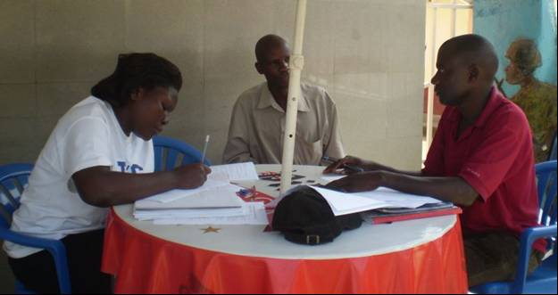
The representative of VI Agro-forestry being interviewed during the OBS

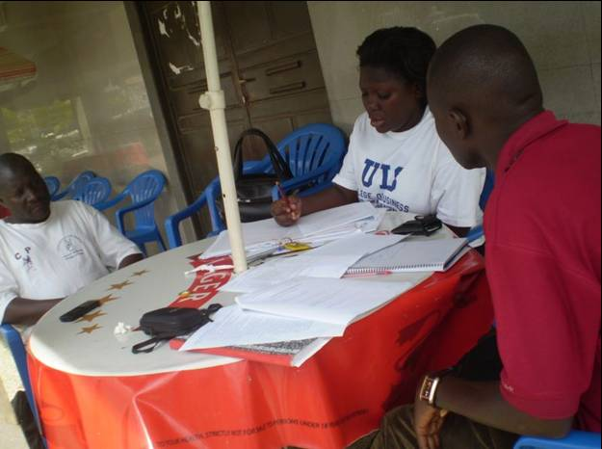
The NAADS sub-county service provider official being interviewed

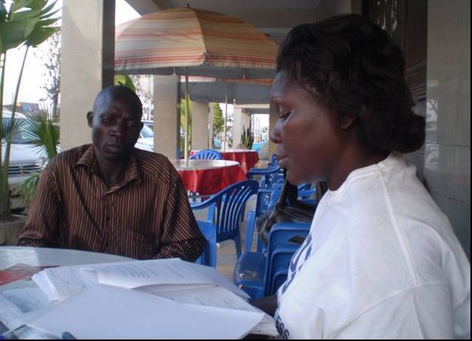
MADDO link farmer being interviewed during the OBS

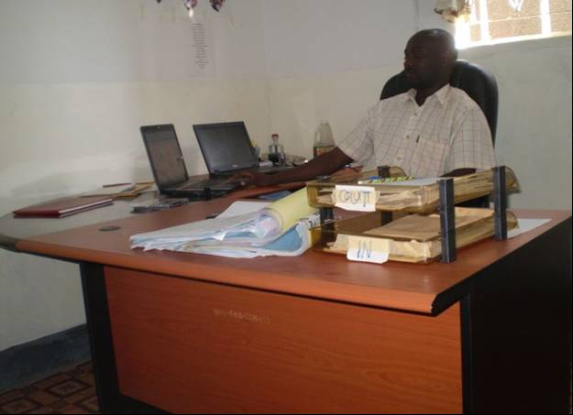
The Acting Program Manager of World Vision Rakai branch being interviewed

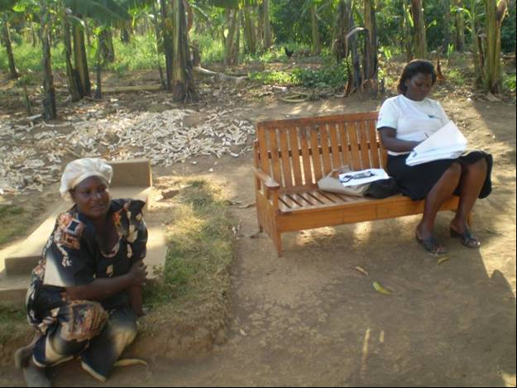
The chairperson of Agali awamu during the OBS interview

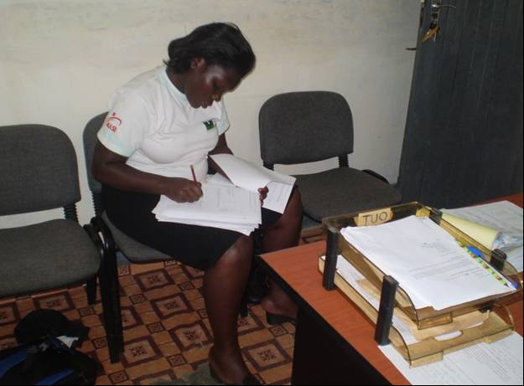
Note-taker filling the questionnaire at World vision Offices in Rakai

The acronyms have either been used in the report or in the questionnaires.

